determinism

There are controversies about how to define determinism. See Earman (1986) for an informative survey. Some difficulties with defining determinism arise in general relativity, in boundary conditions at infinity, and in theories without a fundamental spatio-temporal structure.

definitions of strong determinism will be more robust than those of determinism, because the former only require a notion of the cardinality of models.

strong determinism. According to Penrose (1989), it is “not just a matter of the future being determined by the past; the entire history of the universe is fixed, according to some precise mathematical scheme, for all time” (emphasis original, p.432).

Determinism0 The world is governed by (or is under the sway of ) determinism if and only if, given a specified way things are at a time t, the way things go thereafter is fixed as a matter of natural law.

Hoefer, C. (2016). Causal Determinism. In Zalta, E. N., editor, The Stanford Encyclopedia of Philosophy. Metaphysics Research Lab, Stanford University, Spring 2016 edition.

• A possible world w: a four-dimensional spacetime and its material contents.

• The actual world α: the actual spacetime and its material contents.

• Material contents: material objects and their qualitative properties.

Here the fundamental material contents—the fundamental material objects and their fundamental properties. Examples include but are not limited to Newtonian point particles, their locations, masses, and charges; electromagnetic fields, their strengths, and directions; quantum states of the universe.

assume there are fundamental laws and they play important roles in scientific explanations. Fundamental laws correspond to the basic principles that govern (or optimally describe) the world. In theory T, its fundamental laws correspond to its axioms. Different choices of fundamental laws correspond to the axioms of different candidates for the final theory of physics or the Theory of Everything (TOE). The fundamental laws cannot be explained in terms of deeper principles (Weinberg 1992, p.18). From them we can derive theorems of great importance and explain all significant observable regularities. See also Chen and Goldstein (2021).

类似phase space相空间

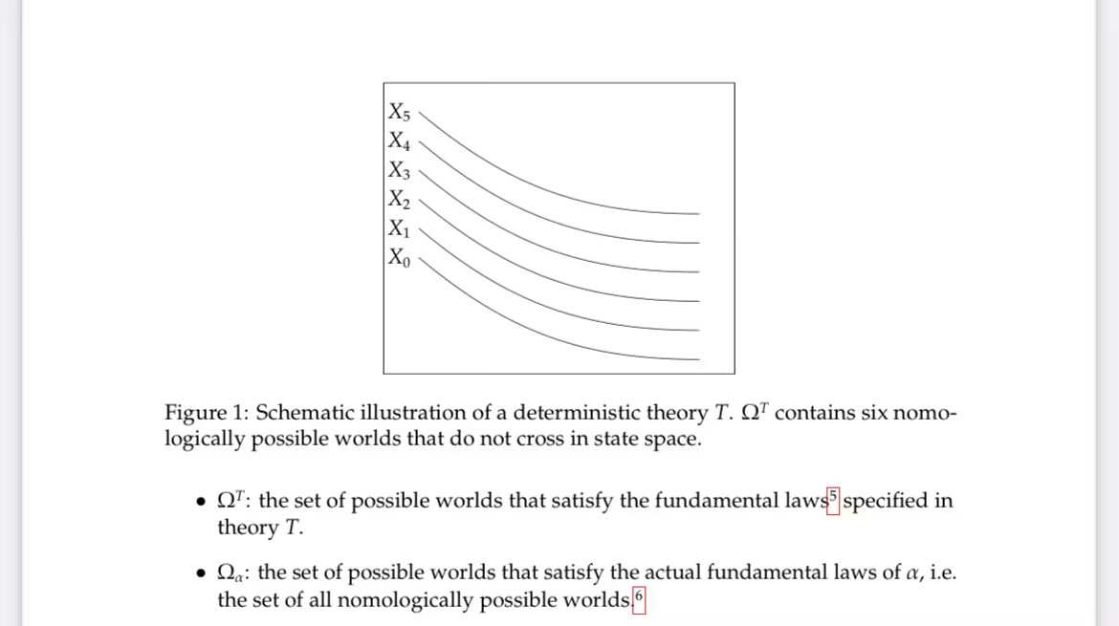

（eddy Chen 5）

DeterminismT Theory T is deterministic just in case, for any two w, w′ ∈ ΩT , if w and w′ agree at any time, they agree at all times.

Determinismα The actual world α is deterministic just in case, for any two w, w′ ∈ Ωα , if w and w′ agree at any time, they agree at all times.

(Earman 1986, p.13) calls Laplacian determinism

Strong DeterminismT Theory T is strongly deterministic if ∣ΩT∣ = 1, i.e. its funda- mental laws are compatible with exactly one possible world.

Strong Determinismα The actual world α is strongly deterministic if Ωα = {α}.

According to Hossenfelder and Palmer (2020), a super-deterministic theory is a deterministic one that is Psi-epistemic, local, and in violation of Statistical Independence. Roughly speaking, a theory is Psi-epistemic just in case the wave function (Ψ) does not correspond to an object (or have an objective status) in the physical world; local just in case there is no “spooky action at a distance” in the sense of Einstein; in violation of Statistical Independence just in case the probability distribution of the fundamental physical variables is not independent of the detector settings.

Hossenfelder, S. and Palmer, T. (2020). Rethinking superdeterminism. Frontiers in

Physics, 8:139.